**Biochemistry**

Draw these compounds.

9. 3 pentanone

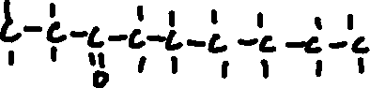

10. propyl propanoate

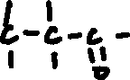

11. 2 amino propanoic acid



12. 2 methyl octanol



13. 4 methyl pentanal



14. 2,4 di-amino 1 butene

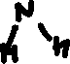

**Biochemistry**

Name and draw structural formulae for each of the following:

1. C5H11 OH

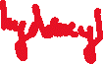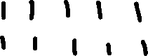

pentanol

2. CH3 CHO



butanal

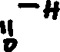

3. (C2H5) CO (CH3)

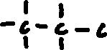

butone



4. (NH2)2 CH CH2 CHO: 1,1-diamino propanal

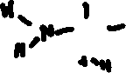

5. (C4H9) COO (C2H5): ethyl butanoate

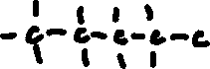

6. (C4H9) O (C3H7): butyl propane ether

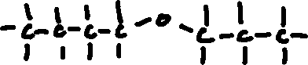

7. C3H7 COOH butanoic acid

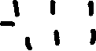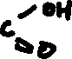

8. (CHO) CH2 (C2H5): butanal

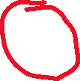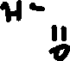

For each structural formula, circle and identify each functional group.